Cognitive Services: Custom Vision

1. Sign up for your free Azure subscription with an outlook.com e-mail address.
   1. If you’re a student, click [here](https://azure.microsoft.com/en-us/free/students/). Otherwise, click [here](https://azure.microsoft.com/en-us/free/).
2. Login to the Azure portal (<https://portal.azure.com>)
   1. Create a new resource

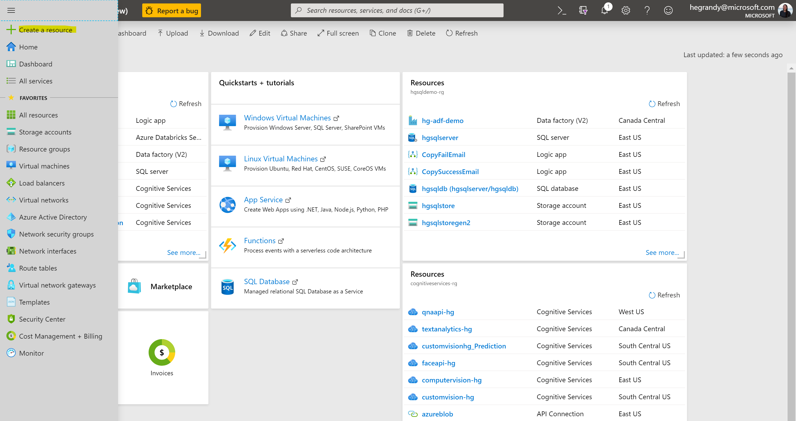

* 1. Search for “Custom Vision”
     1. Specify the name of your Custom Vision resource.
     2. Create a new resource group. A resource group is like a file folder – a logical way to organize your projects.
     3. Select the region where your resource will be provisioned.
     4. Select the pricing tier. You can choose the free tier (F0); the free tier means you will not be charged for calling the Custom Vision services, but the number of calls permitted is limited. This is suitable for testing purposes.
     5. Hit “Create.” It should only take a few seconds to provision the resource.

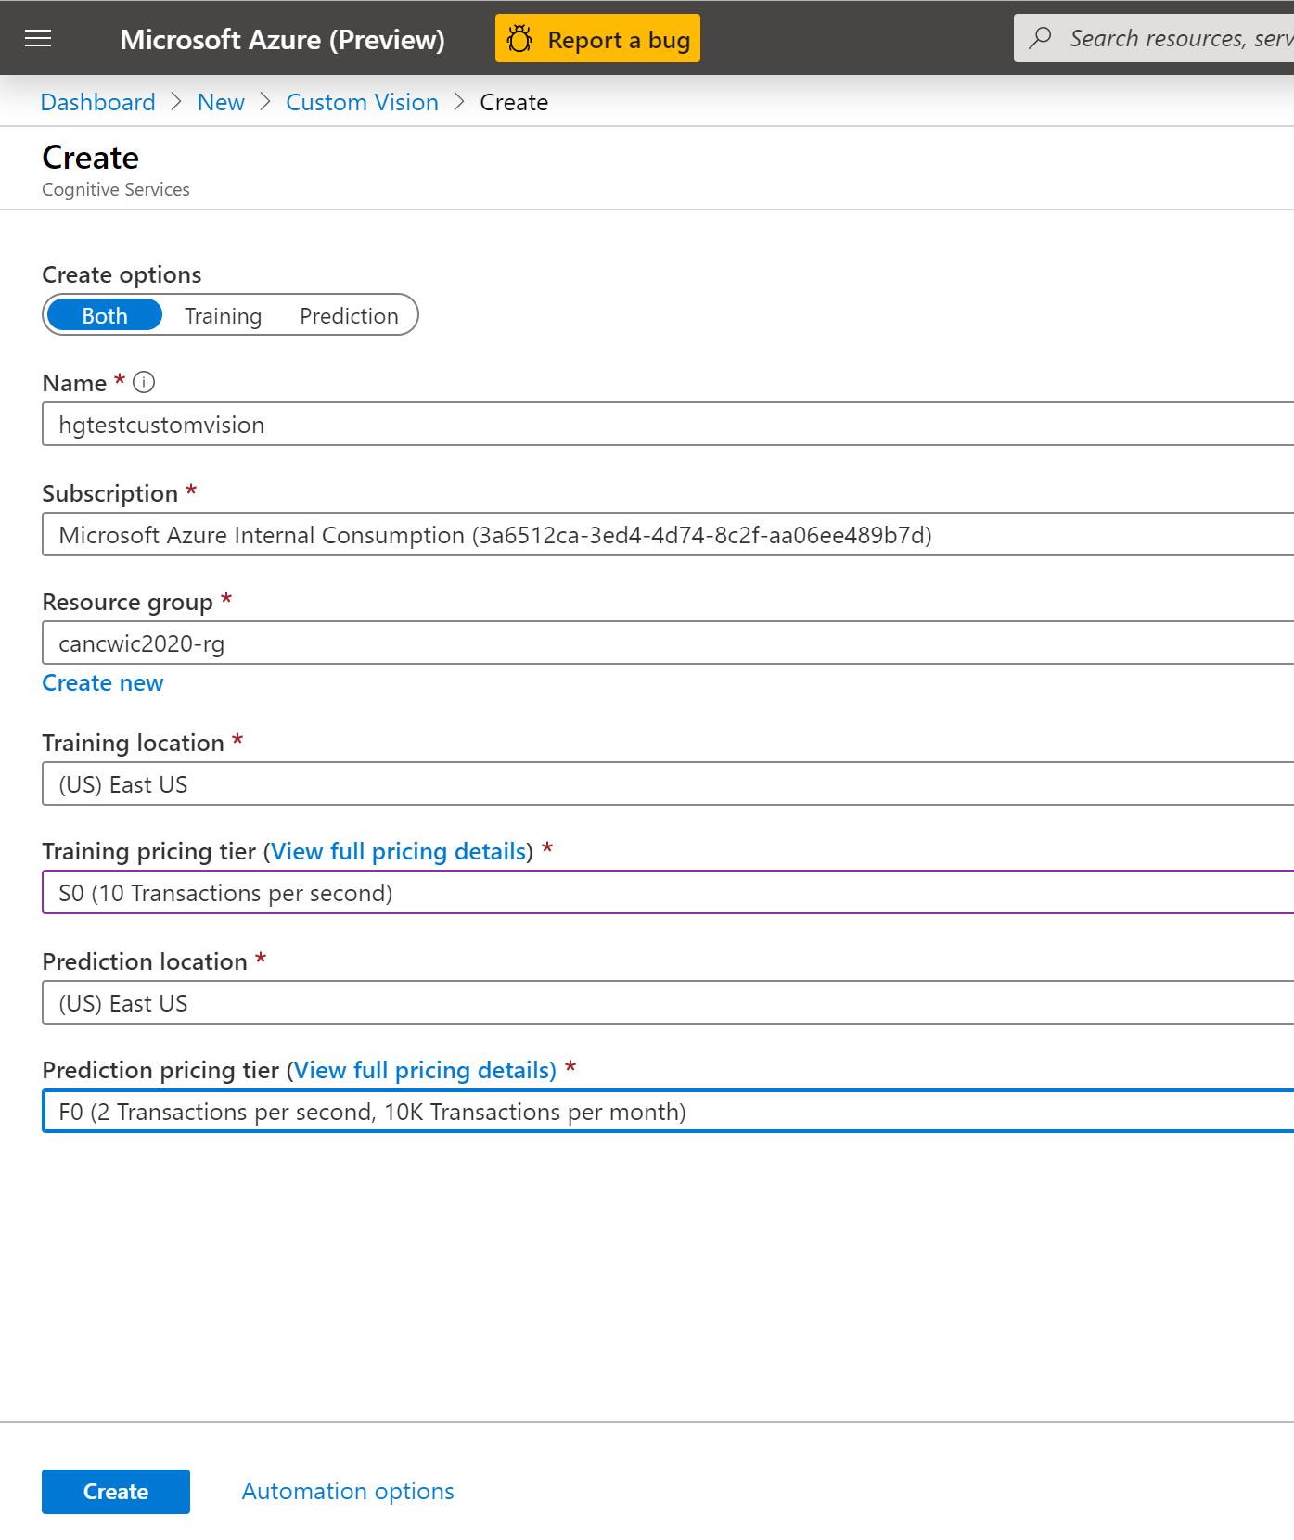

* 1. Once provisioning is complete, take note of your keys (perhaps copy them to a Notepad or OneNote). You will need these keys to connect to your Custom Vision service through an application.
     1. *NOTE*: Two keys should have been created – one for training and one for prediction. It is crucial that the training and prediction keys remain in the same Azure region and resource group. Your Custom Vision project will not work if these keys are moved.
     2. *NOTE*: Use key1 – The second key exists for when you need to perform key rotation only and generally should not be used within your applications.

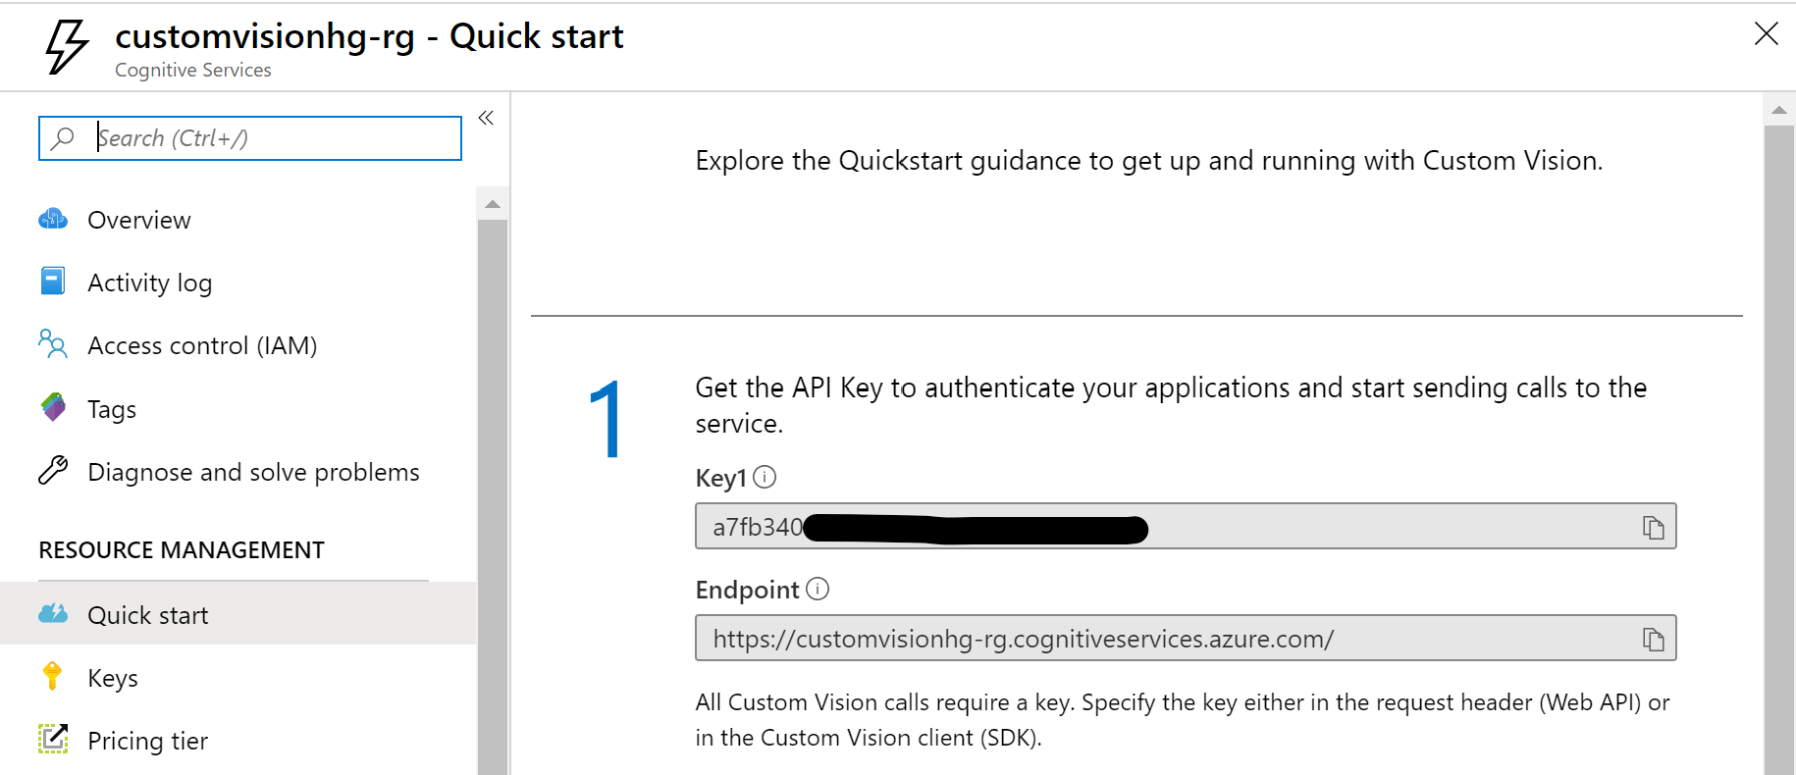

1. Navigate to <https://customvision.ai>
   1. Ensure you are logged in to the correct account (the same one you used to login to the Azure portal).
   2. Select “Create a New Project.”
      1. Specify the Custom Vision service you want to use.
      2. Specify whether you want to create a Classification or Object Detection model. For classification models, you will also have to choose whether it’s a binary model (one tag per image) or a multiclass model (multiple tags per image). Don’t worry, you can edit this after you’ve created your project!
      3. Choose the domain, if applicable. For certain use cases, Custom Vision has optimized models that you can leverage. If your use case does not fall into any of those listed, choose “General.”

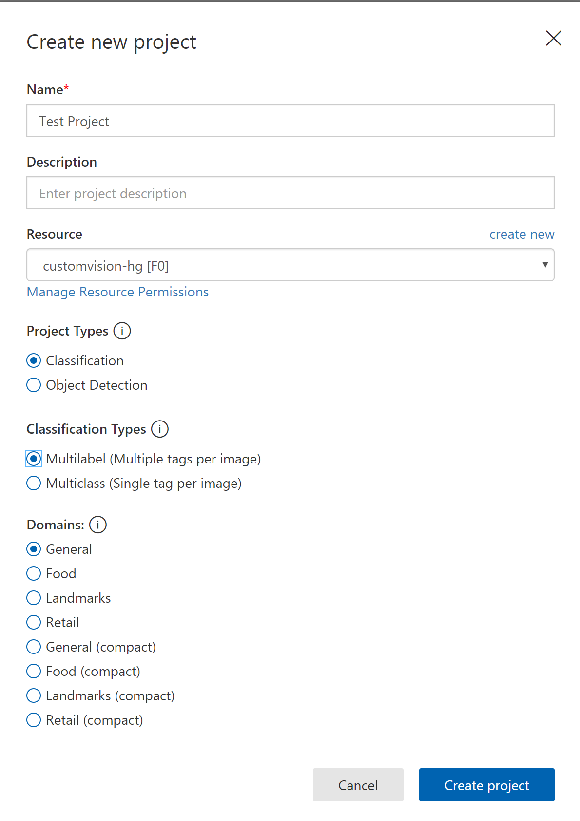

1. Upload images and train a model
   1. Once you have a project, click into it. You will see an empty project.
   2. On the left-hand side of the page, you will see an option to create tags. In the example shown in our session, we used the following tags: tennis, bianca, lowry, kawhi, basketball, raptors, vanvleet, and siakam.
      1. Negative tags: It is important to add negative tags to your model! This will teach your model which images do not have any relation to the other tags you created. For example, we uploaded pictures of city skylines, trees, and people playing sports besides basketball and tennis to improve the accuracy of our model.
   3. You can add images locally or from an Azure storage location like Azure blob storage by selecting “Add training images”. It is recommended to have your images organized beforehand so that you can apply tags to multiple images at once.
      1. Below is an example of what this might look like:

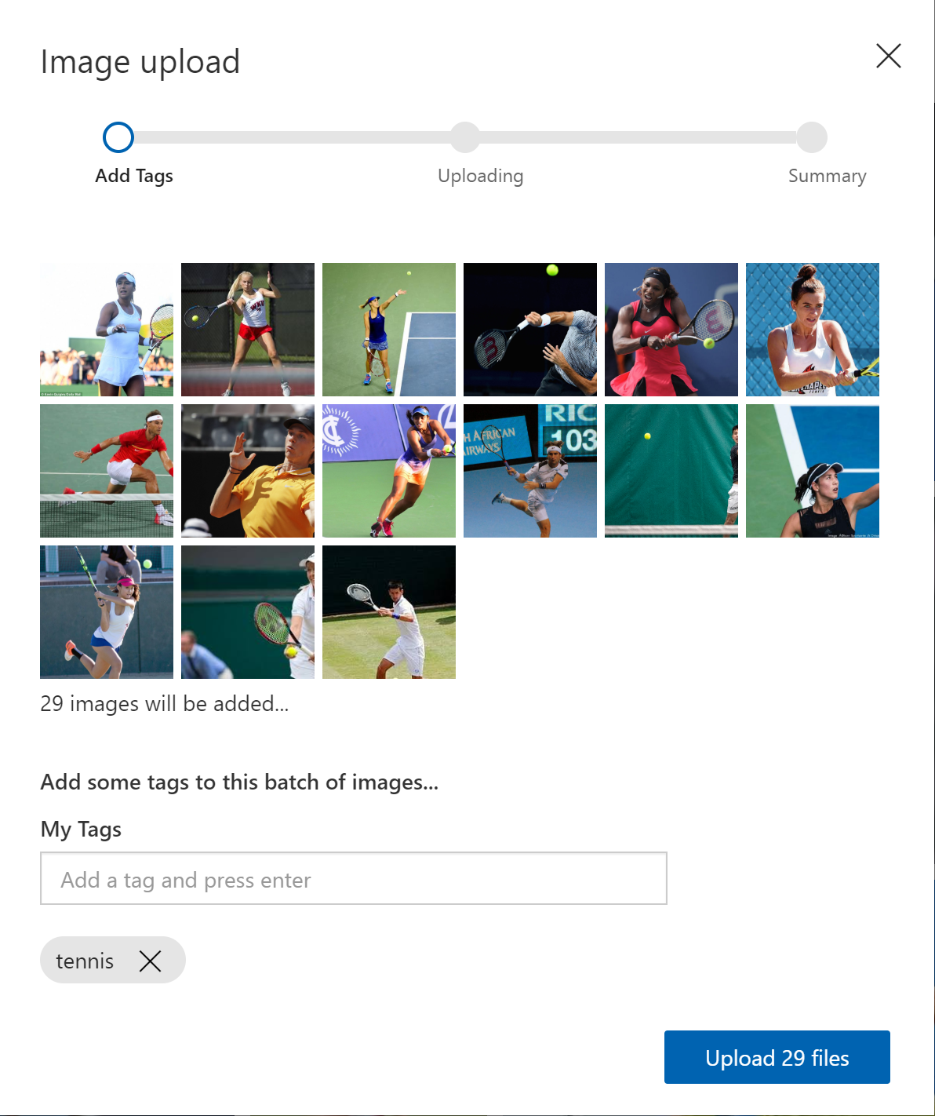

1. Once you have uploaded and tagged your training images, hit the “Train” button in the top right-hand corner. The time to complete depends on how many pictures you’ve uploaded, but it typically takes less than one minute.
   1. After training is complete, you will see accuracy metrics related to the performance of your model. This is particularly useful if you are trying to optimize one of these metrics.
      1. **AP**: A measure of the model performance, summarizes the precision and recall at a different threshold.
      2. **Precision**: If a tag is predicted by your model, how likely is that tag to be right?
      3. **Recall**: Out of the tags that should be predicted correctly, what percentage did your model correctly find?

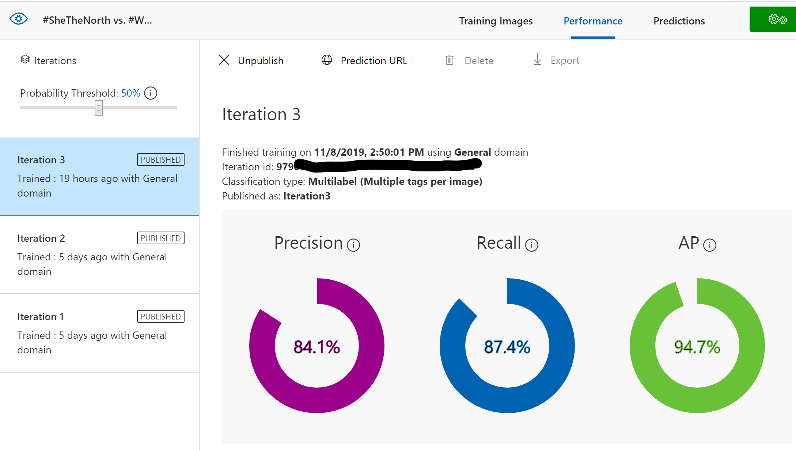

* 1. Test your model using the “Quick Test” button in the top right-hand corner. Specify the URL or file path of the image to view the results. Below is an example of a quick test; an image of Bill Gates at a tennis match was tested against the model. As seen in the screenshot, our model predicted with 82.5% probability that this image showed ‘tennis,’ and did not score any of the other tags as significant. This is the result we would hope for, so we are on the right track!

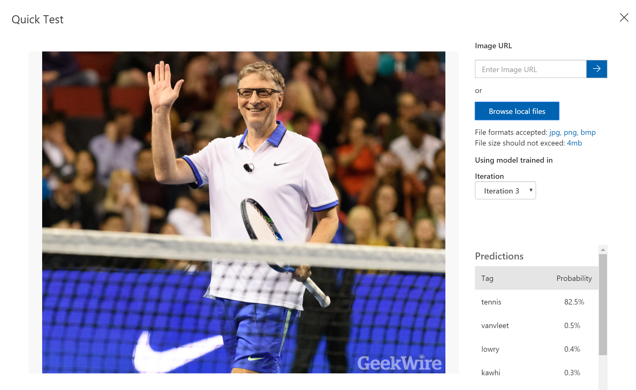

1. If you are satisfied with your model’s performance, you can publish it by clicking on “Publish” under the “Performance” tab. This will generate endpoints and the request schema that you will need to use to call the model from your application.

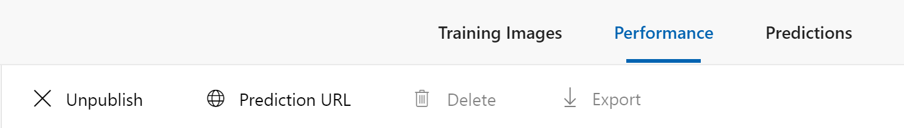

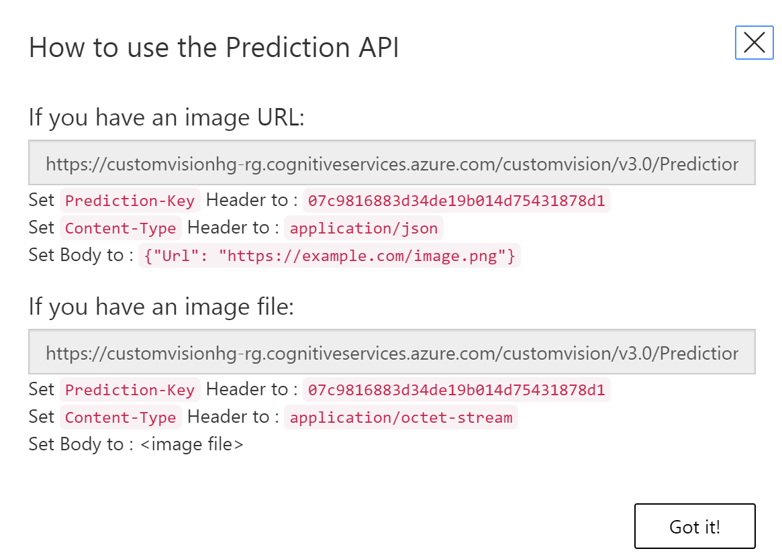

# More Custom Vision Resources

* [What is Custom Vision?](https://docs.microsoft.com/en-us/azure/cognitive-services/custom-vision-service/home)
* [Quickstart: Build a classifier using the portal](https://docs.microsoft.com/en-us/azure/cognitive-services/custom-vision-service/getting-started-build-a-classifier)
* [Quickstart: Build an object detector using the portal](https://docs.microsoft.com/en-us/azure/cognitive-services/custom-vision-service/get-started-build-detector)
* [How to Improve your Model](https://docs.microsoft.com/en-us/azure/cognitive-services/custom-vision-service/getting-started-improving-your-classifier)
* [Use the Prediction API](https://docs.microsoft.com/en-us/azure/cognitive-services/custom-vision-service/use-prediction-api)
* [Limits and Quotas on Custom Vision](https://docs.microsoft.com/en-us/azure/cognitive-services/custom-vision-service/limits-and-quotas)
* [Tutorial on Microsoft Learn: Classify Images with the Custom Vision Service](https://docs.microsoft.com/en-us/learn/modules/classify-images-with-custom-vision-service/)